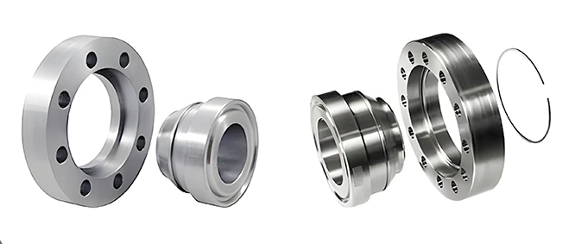
The Role of Flanges in Transformers: Essential Details You Need to Know
Flanges may seem like simple components, but they play a crucial role in the operation and maintenance of transformers. Understanding their types and applications helps highlight their importance in ensuring reliable and efficient transformer performance. Here’s a closer look:

Types of Flanges and Their Uses in Transformers:
- Weld Neck Flanges:
Application: Used in high-pressure and high-temperature transformer systems.
Function: Provides strong support and a secure connection, minimizing the risk of leaks or structural failure.
- Slip-On Flanges:
Application: Common in smaller, lower-pressure transformers.
Function: Easier to install and align, making them suitable for less demanding applications.
- Blind Flanges:
Application: Used to close off the ends of transformer tanks or pipes.
Function: Essential for sealing the transformer and enabling maintenance without draining the entire system.
- Lap Joint Flanges:
Application: Found in systems requiring frequent dismantling.
Function: Ideal for easy assembly and disassembly, simplifying maintenance work.

Key Roles of Flanges in Transformers:
- Sealing and Containment: Flanges ensure that insulating oil or gas remains securely within the transformer, preventing leaks that could compromise performance and safety.
- Structural Integrity: They provide a robust connection between various components, reducing vibrations and enhancing the durability of the unit.
- Ease of Maintenance: Flanges allow for convenient disassembly for part replacement or inspection, significantly reducing downtime.
- Safety Assurance: Properly fitted flanges prevent oil or gas leaks, which could lead to dangerous situations like electrical faults or fires.
At JieZou Power, we prioritize the integration of high-quality, durable flanges in all our transformer models. This commitment ensures our products are not only reliable but also meet industry standards for safety and performance.

**法兰在变压器中的作用：你需要了解的关键细节**
法兰看似简单的组件，但它们在变压器的运行和维护中起着至关重要的作用。了解其类型和应用有助于凸显其在确保变压器可靠和高效性能方面的重要性。以下是详细解析：

**法兰的类型及其在变压器中的应用**
1. **对焊法兰**
- **应用**：用于高压和高温变压器系统。
- **功能**：提供强大的支撑和牢固的连接，最大限度地减少泄漏或结构故障的风险。

2. **平焊法兰**
- **应用**：常见于小型、低压变压器。
- **功能**：易于安装和对齐，适用于要求较低的应用场景。

3. **盲板法兰**
- **应用**：用于封闭变压器油箱或管道的末端。
- **功能**：对于密封变压器至关重要，并可在不排空整个系统的情况下进行维护。

4. **松套法兰**
- **应用**：用于需要频繁拆卸的系统。
- **功能**：便于组装和拆卸，简化维护工作。

**法兰在变压器中的关键作用**
- **密封与包容**：法兰确保绝缘油或气体安全地保留在变压器内，防止泄漏，从而避免性能和安全问题。
- **结构完整性**：它们在各个组件之间提供牢固的连接，减少振动并增强设备的耐用性。
- **便于维护**：法兰便于拆卸以进行部件更换或检查，从而显著减少停机时间。
- **安全保障**：正确安装的法兰可防止油或气体泄漏，避免电气故障或火灾等危险情况的发生。

